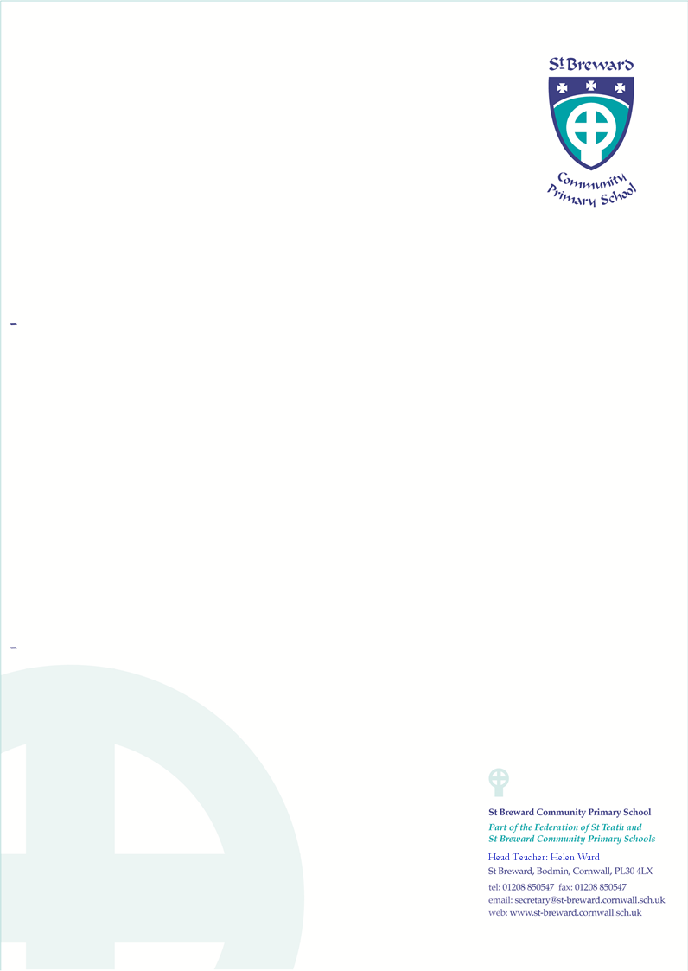

Dolphins visit
Davidstow War Museum
5th September 2019
I wish my son/daughter ……………………………………………………………………………to be allowed to take part in the above-mentioned activity.
The children will be taken in the mini bus.
This is because the class will be studying significant parts of World War 2 as part of their topic in the Autumn term.
They will need to wear their school uniform and bring a packed lunch and drinks.
1. I consent to any emergency medical treatment required by my child during the course of the day.
2. I confirm that my child does not suffer from any medical condition requiring regular treatment OR my child suffers from........................................................ (e.g. diabetes, asthma). (Delete as appropriate) If your child suffers from a particular complaint, please enclose a letter detailing the complaint and its treatment.
___________________________________________________________________________
Signature of Parent/Guardian …………………………………………………… Date…………………..
In the event of an emergency on the day of the visit, please enter below the names and telephone numbers of two people you would like us to contact, if you cannot be reached at your home telephone number.
First Contact | Second Contact
Name……………………………………...  Telephone Number ……………………………. | Name……………………………………...  Telephone Number …………………………….

NOTES St. Breward Primary School has an insurance policy which covers visits/journeys.
The Local Education Authority through its employees and agents will at all times take reasonable care of your child and his/her personal effects. If your child has an accident or suffers loss or damage to his/her personal effects which is not as a result of any lack of care on the part of the LEA, its employees or agents, the LEA will not be able to pay any damages or meet any expenses arising. Similarly, if your child incurs any liability towards a third party in respect, for example, of any injury caused by your child to that third party or damage caused to the third party’s property the LEA will not be responsible for this unless it can be shown to be at fault in some way.

