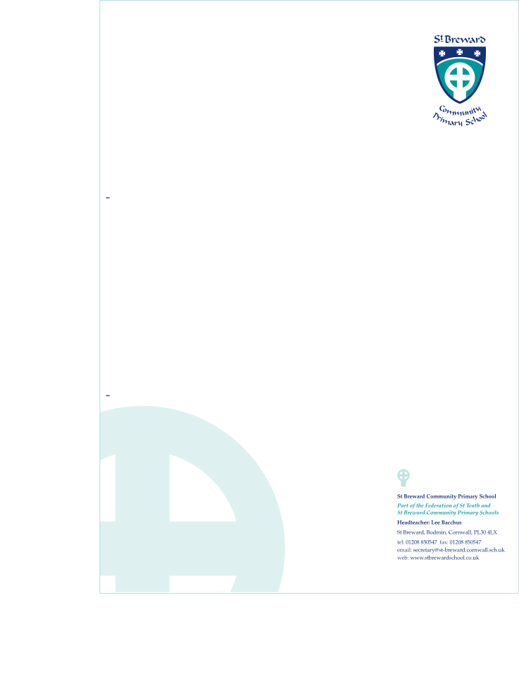

I wish my son/daughter ……………………………………………………………………………to be allowed to take part in the after school activities on the days indicated below. Please tick all that apply. See separate sheet for details.

1. I consent to any emergency medical treatment required by my child during the course of the session.

2. I confirm that my child does not suffer from any medical condition requiring regular treatment **OR** my child suffers from........................................................ (e.g. diabetes, asthma). **(Delete as appropriate)** If your child suffers from a particular complaint, please enclose a letter detailing

|  |  |  |
| --- | --- | --- |
| Monday  ART (free) | Wednesday  STREET DANCE (2.50) | Thursday  Touch rugby (free) |
|  |  |  |

**I confirm that I have booked and paid on the school money site.**

Signature of Parent/Guardian …………………………………………………… Date…………………..

*In the event of an emergency on the day of the visit, please enter below the names and telephone numbers of two people you would like us to contact,* ***if you cannot be reached at your home telephone number.***

|  |  |
| --- | --- |
| First Contact | Second Contact |
| Name…………………………………….....................  Telephone Number ……………………………. | Name……………………………………...  Telephone Number ……………………………. |

**NOTES** St. Breward Primary School has an insurance policy which covers visits/journeys.

The Local Education Authority through its employees and agents will at all times take reasonable care of your child and his/her personal effects. If your child has an accident or suffers loss or damage to his/her personal effects which is not as a result of any lack of care on the part of the LEA, its employees or agents, the LEA will not be able to pay any damages or meet any expenses arising. Similarly, if your child incurs any liability towards a third party in respect, for example, of any injury caused by your child to that third party or damage caused to the third party’s property the LEA will not be responsible for this unless it can be shown to be at fault in some way.

Parental Consent Form

After school clubs

1st Half Autumn Term 19