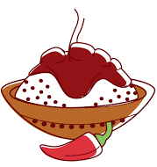
Takeaway

Tomorrow, Monday 14th October at 3pm we are holding a Taster event. Nicki from “CURRY CRAVINGS” will be in the playground shelter with her curries to taste, of which takeaway orders can be taken for takeaway night on the 1st November. If it is successful it could become a regular thing, this is open to the whole community not just parents, as this not being provided by the school. Nicci will give a donation to the school from every meal sold! So have a night off from cooking and come and treat the whole family!
More info regarding ordering etc to come from Nicci @ “CURRY CRAVINGS”

